Natural Selection Explained
Adapted from BBC: GCSE – Evolution
and Chapter 16 Evolutions of Populations
Darwin's theory of evolution explains how species of living things have changed over geological time. The theory is supported by evidence from fossils, and by the rapid changes that can be seen to occur in microorganisms such as antibiotic-resistant bacteria. Many species have become extinct in the past and the extinction of species continues to happen.
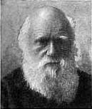
Charles Darwin (1809-1882)
Charles Darwin was an English naturalist. He studied variation in plants and animals during a five-year voyage around the world in the 19th century. He explained his ideas about evolution in a book called On the Origin of Species, which was published in 1859.

Darwin studied the wildlife on the Galápagos Islands - a group of islands on the equator almost 1,000 kilometers west of Ecuador. He noticed that the finches - songbirds - on the different islands there were fundamentally similar to each other, but showed wide variations in their size, beaks and claws from island to island. For example, their beaks were different depending on the local food source. Darwin concluded that, because the islands are so distant from the mainland, the finches that had arrived there in the past had changed over time.

Natural selection
The theory of evolution states that evolution happens by natural selection. Here are the key points:
- Individuals in a species show a wide range of variation (changes).
- This variation is because of differences in genes.
- Individuals with characteristics most suited to the environment are more likely to survive and reproduce.
- The genes that allowed the individuals to be successful are passed to the offspring in the next generation.
Individuals that are poorly adapted to their environment are less likely to survive and reproduce. This means that their genes are less likely to be passed to the next generation. Given enough time, a species will gradually evolve.

Testing Natural Selection in Nature
Now that you know the basic mechanisms of evolutionary change, you might wonder if these processes can be observed in nature. The answer is yes. In fact, some of the most important studies showing natural selection in action involve descendants of the finches that Darwin observed in the Galapagos Islands.

Those finch species looked so different from one another that when Darwin first saw them, he did not realize they were all finches. He thought they were blackbirds, warblers, and other kinds of birds. The species he examined differed greatly in the sizes and shapes of their beaks and in their feeding habits, as shown in the table below. Some species fed on small seeds, while others ate large seeds with thick shells. One species used cactus spines to pry insects from dead wood. One species even picked at the tails of large sea birds and drank their blood!
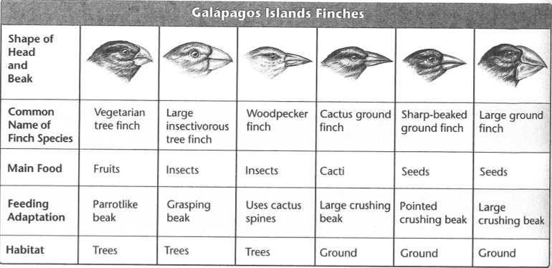

Once Darwin discovered that these birds were all finches, he hypothesized that they had descended from a common ancestor. Over time, he proposed, natural selection shaped the beaks of different bird populations as they adapted to eat different foods.

That was a reasonable hypothesis. But was there any way to test it? No one thought so, until the work of Peter and Rosemary Grant from Princeton University proved otherwise. For more than twenty years, the Grants have been collaborating to band and measure finches on the Galapagos Islands. They realized that Darwin’s hypothesis relied on two testable assumptions. First, in order for beak size and shape to evolve, there must be enough heritable variation in those traits to provide raw material for natural selection. Second, differences in beak size and shape must produce differences in fitness that cause natural selection to occur.

The Grants tested these hypotheses on the medium ground finch on Daphne Major, one of the Galapagos Islands. This island is large enough to support good-sized finch populations, yet small enough to enable the Grants to catch and identify nearly every single bird belonging to the species under study.

Variation
The Grants first identified and measured as many individual birds as possible on the island. They recorded which birds were still living and which had died, which had succeeded in breeding and which had not. For each individual they also recorded characteristics such as wing length, leg length, beak length, beak depth, beak color, feather colors, and total mass. These data indicate that there is great variation of heritable traits among the Galapagos finches.

Natural Selection
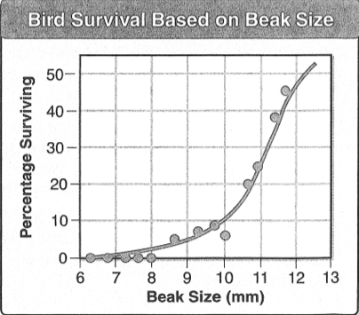
Other researchers who had visited the Galapagos Islands did not see the different finches competing or eating different foods. During the rainy season, when these researchers visited, there is plenty of food. Under these conditions, finches often eat the most available type of food. During the dry-season drought, however, some foods become scarce, and others disappear altogether. At that time, differences in beak size can mean the difference between life and death. To survive, birds become feeding specialists. Each species selects the type of food its beak handles best. Birds with big, heavy beaks, for example, select big, thick, seeds that no other species can crack open.

The Grants’ most interesting discovery was that individual birds with different sized beaks had different chances of survival during the drought. When food for the finches is scarce (not enough), individuals with the largest beaks were more likely to survive, as shown in the graph to the right. The Grants observed that average beak size in that finch population increased dramatically over time.

By documenting natural selection in the wild, the Grants provided evidence of the process of evolution: the next generation of finches had larger beaks than the generation before selection had occurred. An important result of this work was their finding that natural selection takes place frequently – and sometimes very rapidly. Changes in the food supply on the Galapagos caused measurable changes in the population over a period of decades (a decade is 10 years long). This is markedly different from the slow, gradual evolution that Darwin imagined.
Natural Selection Explained Analysis Questions – Answer on a Separate piece of paper
- In your own words create a definition for natural selection.

- What happens to organisms who are not adapted to their environment?

- What was Charles Darwin’s theory about why the finches in the Galapagos Islands have different sized beaks?

- The sharp-beaked ground finch and the large ground finch both eat mostly seeds. Predict why they have very different beak shapes.

- Why was it so important for the Grants to be able to test Darwin’s hypothesis?

- What are the two assumptions the Grants based their experiments on?

- Why would it be important for the Grants to examine and id almost every bird on the island Daphne Major?

- The Grants recorded data on seven finch characteristics. What does this information tell you about the genetic variation of the population?

- Why was the rainy season not an ideal (good) time to study the finches eating habits?

- From this study the Grants made two conclusions. What are they?

- Use the graph Bird Survival Based on Beak Size to answer the following questions. If a finch has a beak size of 11mm what is its percentage of survival?

- What does a 50% chance of survival mean?

