Name: Date:

**Science 10: Genes, Alleles and Punnett Squares**



A _______________ is a segment of DNA that codes for a specific trait.



A pair of _____________________ chromosomes have _________________.



Alleles are alternative forms of your _________________.



Humans have _______________ pairs of homologous chromosomes. One set is from your ___________________ and the other set is from your ____________________.



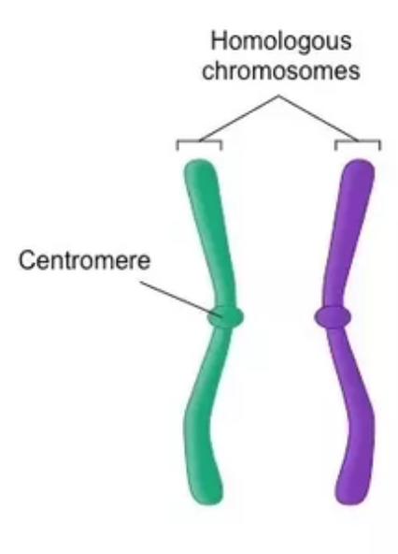

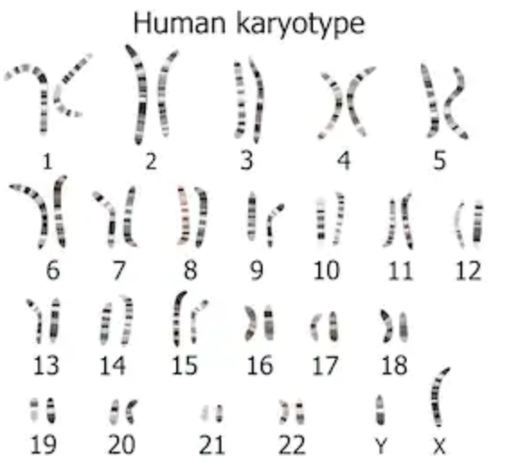



Example:

There is a gene that contributes to eye colour on chromosome 15. You get one copy of this gene from your biological mother and another from your biological father.

***How genes give us our traits:***

*We will use peas as an example organism for simplicity.*

In Gregor Mendel’s experiments with pea plants he noticed that the flowers were either _____________________ or ____________________. Purple is considered the dominant trait, so we use ___________ to represent it. White is considered the recessive trait, so we use ________ to represent it.



Each pea plant will get two allele’s, one from the mother and one from the father. Those allele’s could be either _____________ or ______________ depending on the parent genetics.



So the possible combinations of alleles for the offspring are:



The _________________________ of the pea plant states what allele’s it carries. The ________________________ of the pea plant states what physical trait the pea expresses.



Ie.



|  |  |  |
| --- | --- | --- |
| **If the offspring has…** | **…then the genotype is…** | **…and the phenotype is.** |
| Heterozygous |  |  |
| Homozygous dominant |  |  |
| Homozygous recessive |  |  |



*The Law of Segregation:*



During gamete formation (aka. ________________), the alleles for each gene ______________ from each other so that each gamete carries only one allele for each gene.



In other words, if the parent is heterozygous, it could pass on either __________ or ___________ to its offspring.



*Punnett Square:*

Punnett squares are used to predict the genotype of offspring.

Example:

Two pea-plants are cross-bred. One is heterozygous, one is homozygous recessive. What are the probabilities of each genotype and phenotype occurring in the offspring?



Example:



Two pea-plants are cross-bred. Both are homozygous. What are the probabilities of each genotype and phenotype occurring in the offspring?

