Name: Date:

**Chemistry 12 – Lesson 5 – Kinetic Energy Distributions**



***Kinetic Energy***

The following is a graph of kinetic energy and the number of molecules with each kinetic energy. Note that it is a normal distribution.

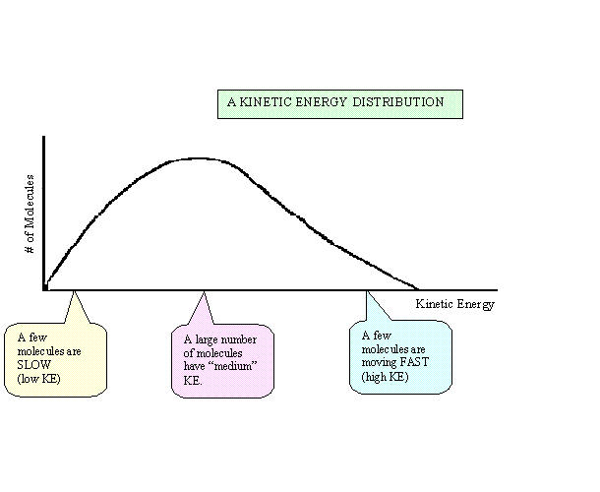

# of Molecules

Kinetic Energy



What happens to the KE distribution when temperature is increased?



# of Molecules

Kinetic Energy



At the higher temperature, there are fewer ________________ molecules and more _____________ molecules.



The curve is more spread out at a higher temperature but the total area under the curve stays the same.



***Activation Energy***



Activation energy is the __________________ energy needed in a collision before a reaction can take place. It is the minimum energy needed for colliding particles to have a _____________________ collision.

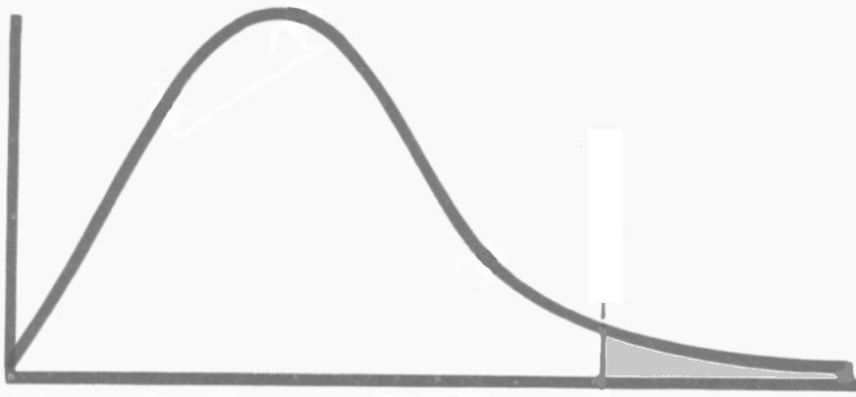

**# of Molecules**

**Kinetic Energy**



*How does an increase in temperature affect the molecules with enough KE?*

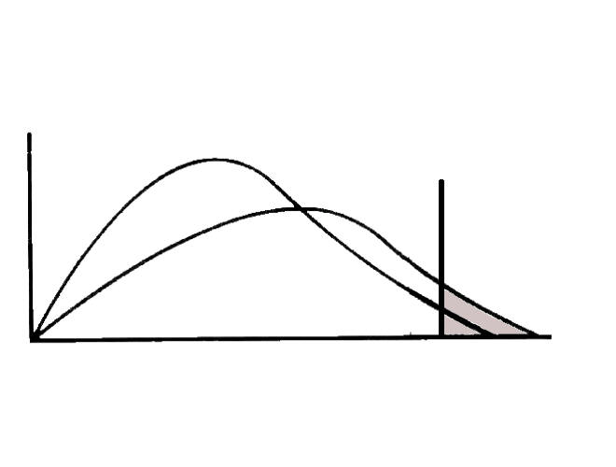

**Number of Molecules**

**Kinetic Energy**



*** For ____________ reactions (ie. When the activation energy is near the tail of the curve)



* IF the temperature is increased by 10°C reaction rate will approximately __________________.



* About ____________ the number of molecules have sufficient KE for a successful collision.

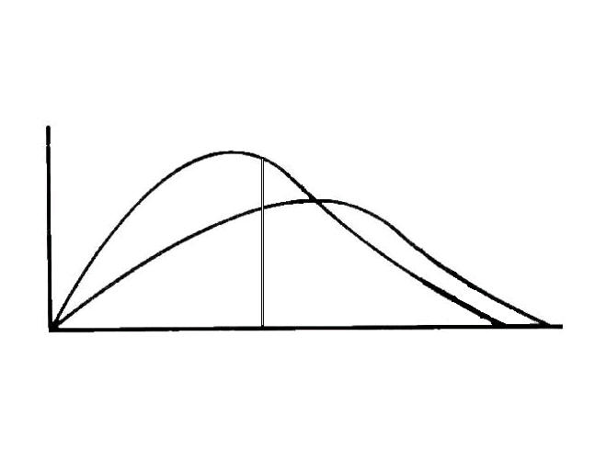

**Number of Molecules**

**Kinetic Energy**



For a reaction that is already fast (ie. Ea is a lot lower), increasing the temperature has much less of an effect on the reaction rate.



Pg. 19-20 #29-32

Pg. 12 #20-22



Pg. 16 #24-28