Sex-Linked Inheritance

Adapted from: https://www.khanacademy.org/science/biology/classical-genetics/sex-linkage-non-nuclear-chromosomal-mutations/a/sex-linkage-sex-determination-and-x-inactivation

Key points:
- In humans and other mammals, biological sex is determined by a pair of sex chromosomes: XY in males and XX in females.
- Genes on the X chromosome are said to be X-linked. X-linked genes have distinctive inheritance patterns because they are present in different numbers in females (XX) and males (XY).
- X-linked human genetic disorders are much more common in males than in females due to the X-linked inheritance pattern.

Introduction
If you’re a human being (which seems like a good bet!), most of your chromosomes come in homologous pairs. The two chromosomes of a homologous pair contain the same basic information – that is, the same genes in the same order – but may carry different versions of those genes.
Are all of your chromosomes organized in homologous pairs? The answer depends on whether you’re (chromosomally) male.
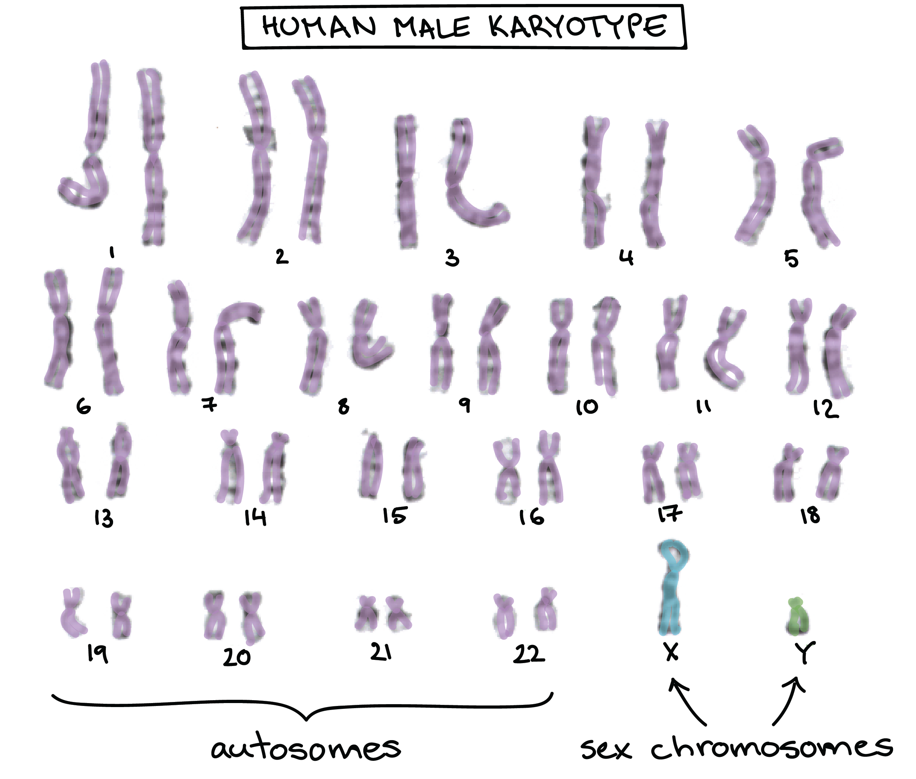
Image of a human karyotype, showing the 44 autosomes in matching pairs and 2 dissimilar sex chromosomes (X and Y),Image modified from "Karyotype," by Can H. (CC BY 2.0).
- A human male has two sex chromosomes, the X and the Y. Unlike the 44 autosomes (non-sex chromosomes), the X and Y don’t carry the same genes and aren’t considered homologous.
- Instead of an X and a Y, a human female has two X chromosomes. These X chromosomes do form a bona fide homologous pair.
Because sex chromosomes don’t always come in homologous pairs, the genes they carry show unique, distinctive patterns of inheritance.

Sex chromosomes in humans
Human X and Y chromosomes determine the biological sex of a person, with XX specifying female and XY specifying male. Although the Y chromosome contains a small region of similarity to the X chromosome so that they can pair during meiosis, the Y chromosome is much shorter and contains many fewer genes.
To put some numbers to it, the X chromosome has about 800−900, protein-coding genes with a wide variety of functions, while the Y chromosome has just 60−70 protein-coding genes, about half of which are active only in the testes (sperm-producing organs) ^{1,2,3,4}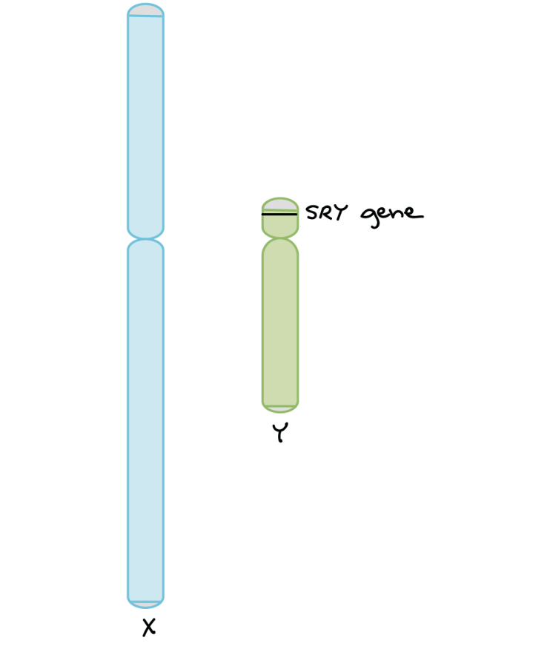
Diagram of the human X and Y chromosomes. The X is much larger than the Y. The X and Y have small regions of homology at both tips, which allow pairing of the chromosomes during meiosis. The SRY gene is found on the Y chromosome, near the tip, just below the region of homology with the X chromosome. Image based on ideograms from the Genome Decoration Page, maintained by the U.S. NCBI.

The human Y chromosome plays a key role in determining the sex of a developing embryo. This is mostly due to a gene called SRY (“sex-determining region of Y”). SRY is found on the Y chromosome and encodes a protein that turns on other genes required for male development
- XX embryos don't have SRY, so they develop as female.
- XY embryos do have SRY, so they develop as male.
In rare cases, errors during meiosis may transfer SRY from the Y chromosome to the X chromosome. If an SRY-bearing X chromosome fertilizes a normal egg, it will produce a chromosomally female (XX) embryo that develops as a male. If an SRY-deficient Y chromosome fertilizes a normal egg, it will produce a chromosomally male embryo (XY) that develops as a female

[Do all species with X and Y chromosomes have the SRY gene?]

No, not all of them. The molecular mechanisms of sex determination vary greatly among species, even those that use an X-Y sex determination system. In most placental mammals, SRY is found on the Y chromosome and is used for sex determination. However, the SRY gene is not present in other species with X-Y sex determination systems, such as fruit flies and other insects9^9​9​​start superscript, 9, end superscript.

X-linked genes
When a gene being is present on the X chromosome, but not on the Y chromosome, it is said to be X-linked. X-linked genes have different inheritance patterns than genes on non-sex chromosomes (autosomes). That's because these genes are present in different copy numbers in males and females.

[What about genes on the Y?]
Genes on either the X or the Y have unusual inheritance patterns and are called sex-linked, but X-linkage is much more common than Y-linkage (since there are many more genes on the X than the Y).
Since a female has two X chromosomes, she will have two copies of each X-linked gene. For instance, in the fruit fly Drosophila (which, like humans, has XX females and XY males), there is an eye color gene called white that's found on the X chromosome, and a female fly will have two copies of this gene. If the gene comes in two different alleles, such as X^{W} (dominant, normal red eyes) and X^{w} (recessive, white eyes), the female fly may have any of three genotypes: X^{W}X^{W} (red eyes), X^{W}X^{w}(red eyes), X^{w}X^{w} (white eyes).
A male has different genotype possibilities than a female. Since he has only one X chromosome (paired with a Y), he will have only one copy of any X-linked genes. For instance, in the fly eye color example, the two genotypes a male can have are X^{W}Y(red eyes) and X^{w}Y (white eyes). Whatever allele the male fly inherits for an X-linked gene will determine his appearance, because he has no other gene copy—even if the allele is recessive in females. Rather than homozygous or heterozygous, males are said to be hemizygous for X-linked genes.

We can see how sex linkage affects inheritance patterns by considering a cross between two flies, a white-eyed female X^{w}X^{w} and a red-eyed male X^{W}Y. If this gene were on a non-sex chromosome, or autosome, we would expect all of the offspring to be red-eyed, because the red allele is dominant to the white allele. What we actually see is the following:
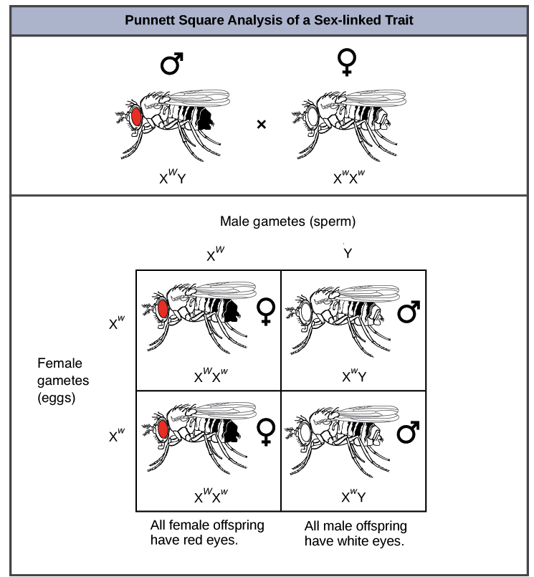
Image credit: "Characteristics and traits: Figure 10," by OpenStax College, Biology, CC BY 4.0

However, because the gene is X-linked, and because it was the female parent who had the recessive phenotype (white eyes), all the male offspring—who get their only X from their mother—have white eyes (X^{w}Y). All the female offspring have red eyes because they received two Xs, with the X^{W} from the father concealing the recessive X^{w} from the mother.

X-linked genetic disorders
The same principles we see at work in fruit flies can be applied to human genetics. In humans, the alleles for certain conditions (including some forms of color blindness, hemophilia, and muscular dystrophy) are X-linked. These diseases are much more common in men than they are in women due to their X-linked inheritance pattern.
Why is this the case? Let's explore this using an example in which a mother is heterozygous for a disease-causing allele. Women who are heterozygous for disease alleles are said to be carriers, and they usually don't display any symptoms themselves. Sons of these women have a 50% chance of getting the disorder, but daughters have little chance of getting the disorder (unless the father also has it), and will instead have a 50% chance of being carriers.
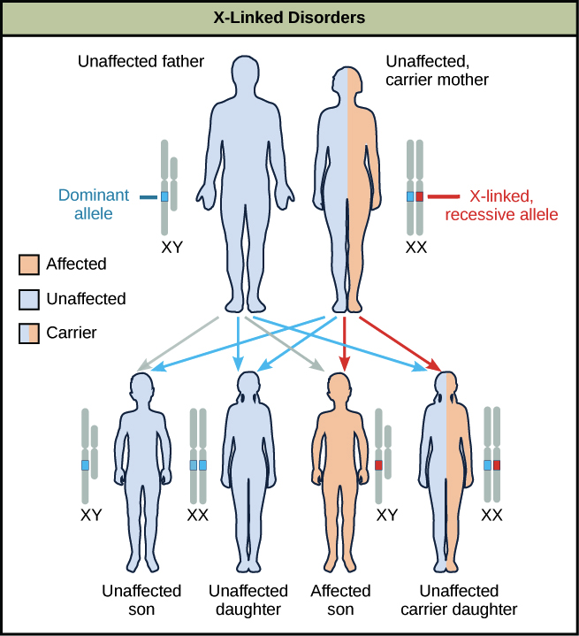
A diagram shows an unaffected father with a dominant allele and an unaffected carrier mother with an x-linked recessive allele. Four figures of offspring are shown representing the various resulting genetic combinations: unaffected son, unaffected daughter, affected son, and unaffected carrier daughter.Image credit: "Characteristics and traits: Figure 10," by OpenStax College, Biology, CC BY 4.0

Why is this the case? Recessive X-linked traits appear more often in males than females because, if a male receives a "bad" allele from his mother, he has no chance of getting a "good" allele from his father (who provides a Y) to hide the bad one. Females, on the other hand, will often receive a normal allele from their fathers, preventing the disease allele from being expressed.

Case study: Hemophilia
Let's look at a Punnett square example using an X-linked human disorder: hemophilia, a recessive condition in which a person's blood does not clot properly. A person with hemophilia may have severe, even life-threatening, bleeding from just a small cut.
Hemophilia is caused by a mutation in either of two genes, both of which are located on the X chromosome. Both genes encode proteins that help blood clot. Let's focus on just one of these genes, calling the functional allele X^{H} and the disease allele X^{h}.

In our example, a woman who is heterozygous for normal and hemophilia alleles(X^{H}X^{h}) has children with a man who is hemizygous for the normal form (X^{H}Y). Both parents have normal blood clotting, but the mother is a carrier. What is the chance of their sons and daughters having hemophilia?
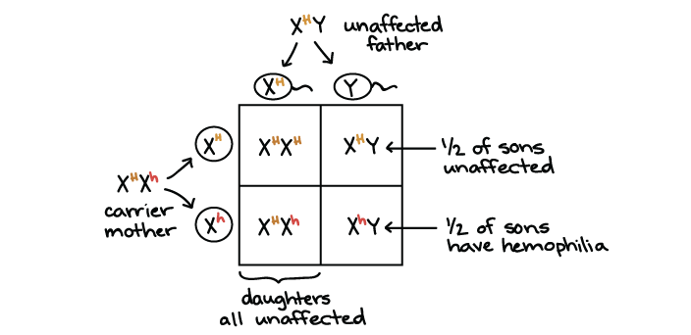
Since the mother is a carrier, she will pass on the hemophilia allele (X^{h}) on to half of her children, both boys and girls.
- None of the daughters will have hemophilia (zero chance of the disorder). That's because, in order to have the disorder, they must get a X^{h} allele from both their mother and their father. There is 0 chace of the daughters getting an X^{h} allele from their father, so their overall chance of having hemophilia is zero.
- The sons get a Y from their father instead of an X, so their only copy of the blood clotting gene comes from their mother. The mother is heterozygous, so half of the sons, on average, will get an X^{h} allele and have hemophilia (50% chance of the disorder).

