Name: Date:

Science 10: Genetics Study Guide

Big Idea: DNA is the basis for the diversity of living things
Learning Target
1-5 | compare how natural and artificial selection impact a population

Step 1: Use the following target symbols to assess your level of understanding:

Bullseye! I know/ understand this and am confident with it.  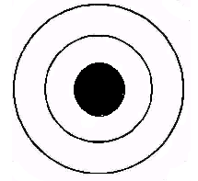 | 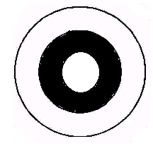  Almost there. I have some knowledge of this but am not totally confident. I could use some further review. | 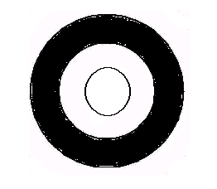  Needs work. I am not confident that I know it. I need to work at this.

Outcomes | 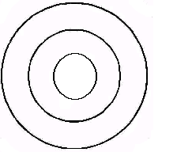Target
I know how natural selection influenced peppered moths, deer mice, and peacocks

I know what causes natural selection to occur

I can identify artificial selection vs. natural selection when given a situation

I know what makes and individual ‘fit’ in biology | 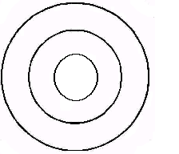
I can explain the process of artificial selection given a specific example to explain with.

I can explain the difference between natural and artificial selection and give examples of both

Given a situation (as demonstrated in class) I can identify how natural selection is driving the evolution of a population because of climate change

Step 2: Make your own Study Review

Examine the targets above. Your studying priority should be the “Needs work” targets. Then you can focus on the “Almost there” targets. Design a study plan that will help you meet these outcomes.

I most need to work on: ______________________________________________________________________
____________________________________________________________________________________________________________________________________________________________________________________
To do this I am going to: _____________________________________________________________________
______________________________________________________________________________________________________________________________________________________________________________________________________________________________________________________________________________
Step 3: Study! Begin your study review!

TEST IS _____________________________________________________.

Ideas for making your own study reviews…

